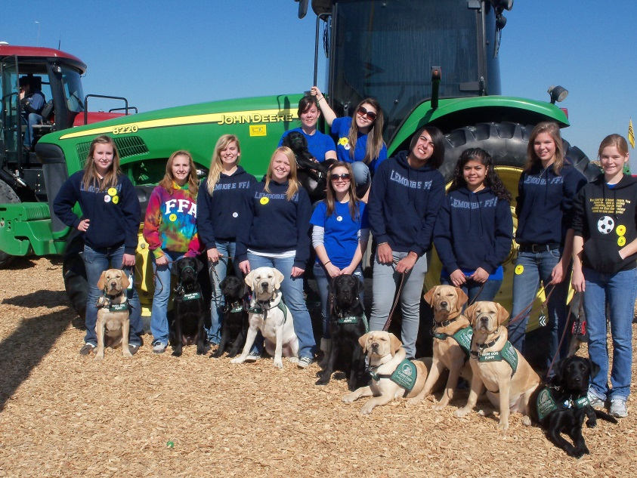
FFA SAE Project
Raise a puppy,
change a life
Guide Dogs for the Blind provides highly trained canine partners to the blind and visually impaired. We have been doing so since 1942 when blinded veterans began returning home, injured in World War II. As the largest guide dog school in North America, we have over 2,000 guide dog teams in the United States and Canada. All of our services are offered at no expense to our clients. We are totally funded by private donations and otherwise supported by close to three thousand volunteers, including our puppy raisers.
Our puppy raisers are vital to our mission. These remarkable people take our puppies into their homes and hearts. They train, socialize, and otherwise prepare these puppies to return to one of our training facilities for formal guide dog training and, hopefully, an eventual career as a guide dog.
Yes, giving up a puppy you raise is hard. We like to say, though, that it is a lot like sending children off to college. Parents do the very best job they can in raising them, teaching them what is right and wrong, providing them with every opportunity to succeed and then sending them off on their own to the start of a new life based on the foundation that they gave them.
While the dogs are being trained, we send our puppy raisers “report cards” on how the puppies that they raised are doing in training. When a dog graduates with its new blind or visually impaired partner, puppy raisers are invited to graduations. Many puppy raisers and their dog’s new partner begin friendships that last a lifetime.
Most of us can only begin to imagine the enormity of the gift that our puppy raisers provide to the people that we serve. Raising a guide dog puppy can truly change a life. The lives that are changed, though, go beyond those of the people who are blind and visually impaired who receive a guide dog. Puppy raisers’ lives are changed, too, particularly youth puppy raisers.
Raising a puppy teaches a young person many life skills, including responsibility, leadership, commitment, patience, humility, nurturing, sacrifice, success (and, at times, failure), and the gift of giving to others even when it is hard on oneself.

And… it’s fun!

We are looking for students who would like to raise a puppy for their FFA SAE project.

For more information about Guide Dogs for the Blind puppy raising, please email your telephone number to ipuppy@guidedogs.com and one of our representatives will call you back.

