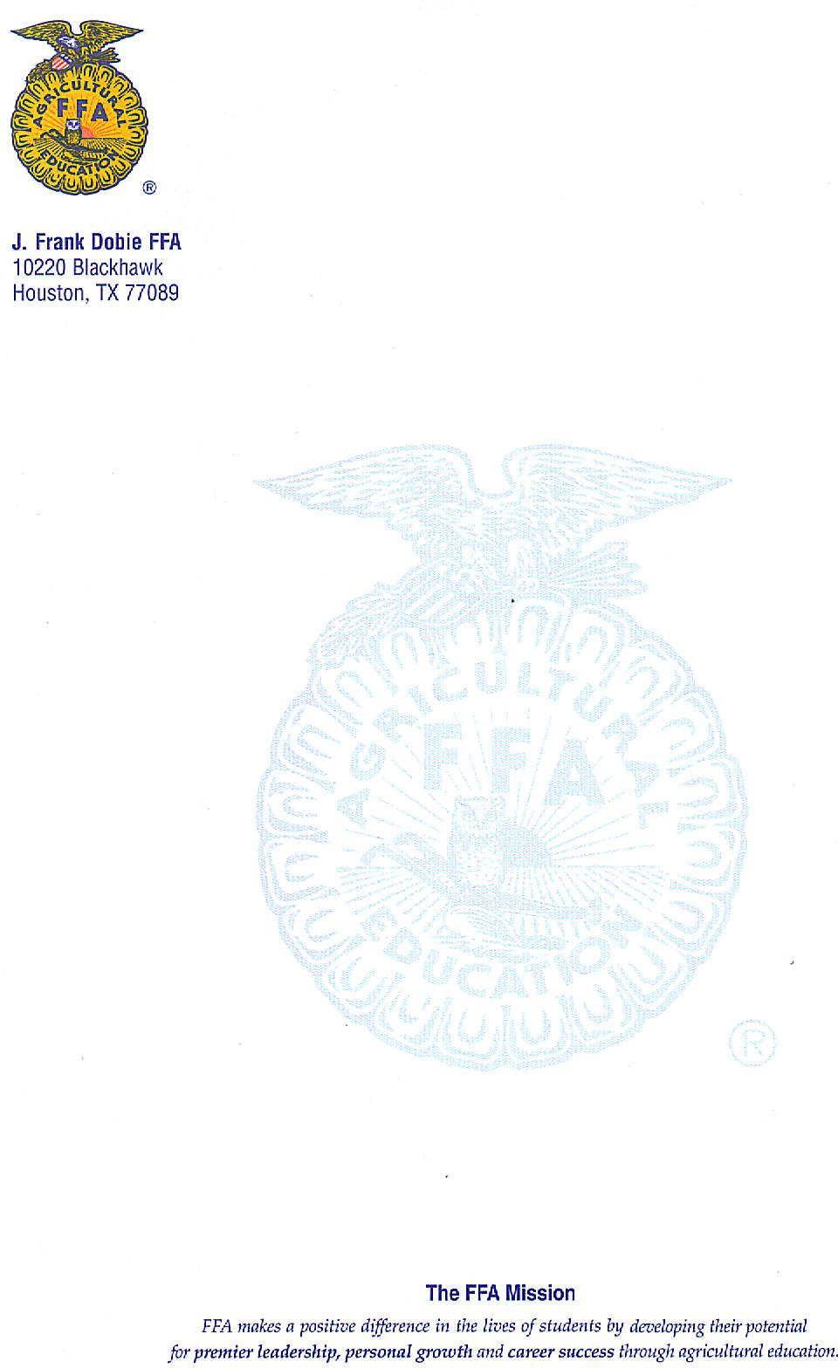

To whom it may concern,

This letter is on behalf of the agricultural students at J. Frank Dobie High School and their FFA program. Agricultural Education prepares students for successful careers and a lifetime of informed choices in the global agriculture, food, fiber and naturalresourcessystems*.* Dobie’s FFA program is dedicated to making a positive difference in the lives of students by developing their potential for premier leadership, personal growth and career success through agricultural education. The chapter is working to expand itself and grow as a program. The students are involved in a number of different activities such as: live animal barn, greenhouse management, metal fabrication shop, and veterinary studies. Our program would greatly appreciate if you would consider sponsoring a student member. Your sponsorship money will go towards their agricultural program of choice. All of these programs will enter many contests and shows during the sponsorship year. Students have the opportunity to participate in Pasadena Livestock Show and Rodeo, Houston Livestock Show and Rodeo, San Antonio Livestock Show and Rodeo and many others. Students will also be competing in Career Development Events such as Livestock evaluation, Nursery and Landscape Evaluation, and speaking events. Our agricultural programs are in constant need of funding that will allow more students to be able to participate. We would greatly appreciate your consideration of being a Dobie FFA sponsor.

Thank you for your support,

Schuyler Morris

Robert McGuill

Anabelle Sallee

EIN #47-4905509